- Identify the Pictures below.
Select your answers from the following choices. Write only the letter.
- Voyager
- Dawn Express
- Japan Hiten
- Mars Lander
- Luna 9
- NEAR Shoemaker

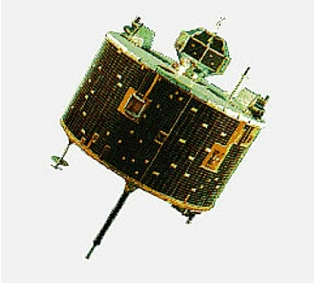
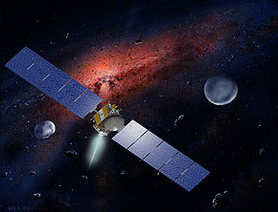

- __________________
- __________________
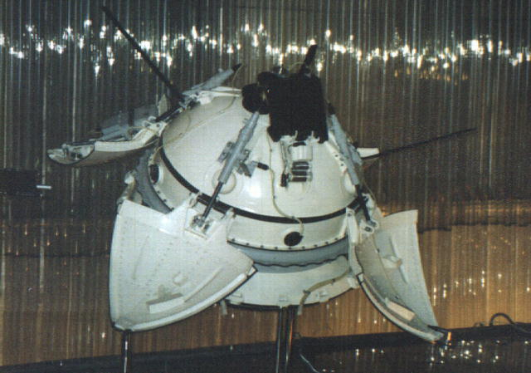
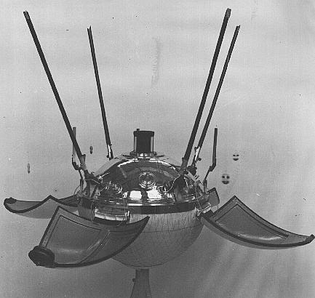

- __________________
- __________________

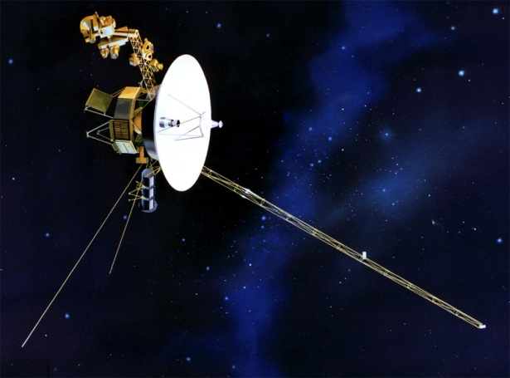

- __________________

- ESSAY (5 PTS.)
1. Explain the main function of NASA.
1. What are the tools used in space exploration? Give their functions.
2. Give 3 types of telescopes and differentiate each one of them.
3. What is the importance of studying celestial bodies?

